5th Annual ALD Standards of Care Conference
January 13-16, 2021
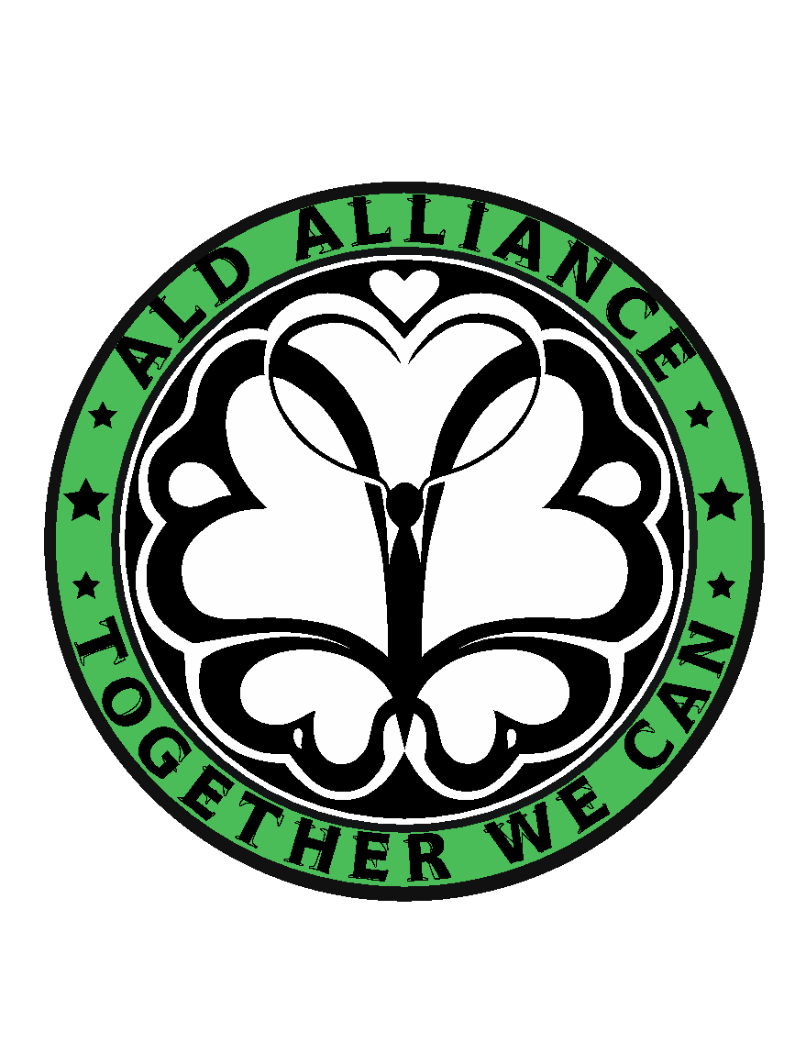
GENERAL MEETING
Thursday, January 14 - Friday, January 15, 2021
11:00AM - 1:00PM & 2:00PM - 4:00PM Eastern

Thursday, January 14, 2021

11:00AM - 11:15AM: Welcome
Elisa Seeger, Miranda McAuliffe & Sarina Rao

11:15AM - 11:45AM: ALD Newborn Screening Roundtable Update
Michele Caggana, ScD, FACMG - NYS Dept. of Health

11:45AM - 12:00PM: Legislative Updates
Elisa Seeger, Miranda McAuliffe, Emily Fields - bluebird bio

12:00PM - 12:30PM: GVHD
Jaap-Jan Boelens, MD, PhD - MSKCC

12:30PM - 1:00PM: Newborn Screening Parent Experience
Sarah Tong - Massachusetts

1:00PM - 2:00PM: BREAK

2:00PM - 3:00PM: Neurology and Endocrinology Guidelines
NYS Lab Project
Eric J. Mallack, MD - NY-Presbyterian/Weill Cornell Medicine
Molly O. Regelmann, MD - The Children’s Hospital at Montefiore

3:00PM - 3:30PM: ALD Registry
Paul Orchard, MD - University of Minnesota

3:30PM - 4:00PM: Neurodevelopmental Testing in ALD
Aram Kim, MD - UPMC Children’s Hospital of Pittsburgh

GENERAL MEETING
Thursday, January 14 - Friday, January 15, 2021
11:00AM - 1:00PM & 2:00PM - 4:00PM Eastern

Friday, January 15, 2021

11:00AM - 11:30AM: Newborn Screening Parent Experience
Amanda Valdez - Minnesota

11:30AM - 12:00PM: ALD CME Webinar Overview
Chris Napolitan, Vice President - PRIME Education

12:00PM - 1:00PM: Updates in Vitamin D
Josh Bonkowsky, MD, PhD - University of Utah
Keith Van Haren, MD - Stanford University Medical Center

1:00PM - 2:00PM: LUNCH

2:00PM - 3:00PM: Telehealth for ALD Panel
Led by: S. Ali Fatemi, MD, CMO - Kennedy Krieger Institute
Catie Becker, NP - Massachusetts General Hospital
Chris Porter - Travere Therapeutics
Amena Smith Fine, MD, PhD - Kennedy Krieger Institute

3:00PM - 4:00PM: Navigating the Psychological Impact of ALD:
Family Panel & Discussion
Led by: Rene Pierpont, PhD - University of Minnesota
Jill Smith, ALD Parent - New Hampshire
Tara Meady, RN, ALD Parent - Connecticut
Sydne Pantaleon, ALD Parent - Illinois

-END GENERAL MEETING-
ALD FAMILY DAY
Saturday, January 16, 2021
12:45PM - 3:00PM

12:45PM: Please sign on early so that we can work out any technical difficulties ahead of time!
1:00PM – 1:30PM: Q&A with ALD Experts - Dr. Regelmann & Dr. Mallack
1:30PM – 1:50PM: Meet author Jackson Grant from “The Donut That Roared”
1:50PM – 2:30PM: Magic Show by Steve the Magician
2:30PM – 3:00PM: Free Talk

Thank you to our Sponsors for making this possible!!!

